**Simulation and Analysis of a Supermarket Queueing System**

Alliyah Camille M. Gonzales Kenshiro M. Nonan

*Technological University of the Philippines Technological University of the Philippines*

alliyahcamille.gonzales@tup.edu.ph kenshiro.nonan@tup.edu.ph

Dann Carlo C. Pulong

*Technological University of the Philippines*

danncarlo.pulong@tup.edu.ph

***Abstract - The purpose of this research is to construct a computer simulation model for improving the queuing system at a supermarket using Discrete Event Simulation (DES), as well as to suggest the most efficient supermarket queuing system for overall improvement. The time study was used to collect data from ABC Supermarket. This study used modelling and simulation as its methodology. Simio Simulation Software is used to create the model that will be utilized to replicate the actual system. The system's calculated p-value is 0.3732, indicating that the created model does not differ significantly from reality. Overall, this study contributes to a better knowledge of the performance of the queuing system.***

***Keywords -*** *Supermarket, Queueing System, Simio simulation, simulation, Discrete Event Simulation (DES)*

1. INTRODUCTION

We encounter delays and queueing problems in our daily-life situations, may it be at a bank, postal office, ticketing office, in public transportation or in a traffic jam but also in more technical environments, such as in manufacturing, computer networking and telecommunications (Igwe, 2014)[3]. Waiting in a line or in a queue became a normal thing, especially in the organisations that generate profit (Priyangika, 2016)[10]. An example of this is at a restaurant where a customer is required to enter a queue to order and be served. If the system management was inefficient, customers would face long queuing and require long waiting times.

A queue at a shopping mall or supermarket is a common occurrence; this queue generally happens while waiting to make a purchase or payment at the cashier. In this situation, customers frequently waste time and are inefficient. The simulation method is used in this study to provide a possible solution for the supermarket in determining the number of cashiers. ABC Supermarket is a small supermarket store in Bagong Barrio, Caloocan City that sells all the necessities of daily life such as groceries, beverages, household products, and so on. With the various necessities provided by ABC supermarket, the place is constantly packed, resulting in a long queue at the checkout. Due to this, the quality of service will be decreased. The study of (Kar, 2014)[5] stated that most supermarket customer satisfaction lies in a short period of checkout process.

The objective of this study is to create a simulation of the supermarket queueing system. The study aims for the simulation to get as close as queueing systems in real-life scenarios. The data that was given in the study is observed at ABC Supermarket.

1. REVIEW OF RELATED STUDIES
2. Supermarket

A supermarket is an establishment with at least 2,000 square feet sales area, operated primarily through self-service, with three or more checkouts, and whose inventory includes all food groups, including fresh meat, fresh fruits, and vegetables, as well as essential household items (i.e., soaps and cleaning materials) (McClelland, 1962)[8].

1. Queueing System

The system of waiting in lines or queuing up has three components. Arrivals, queue protocol, and the service facility are all parts of the queuing system. Figure 2 depicts the system of waiting lines (Heizer & Render, 2014)[2].

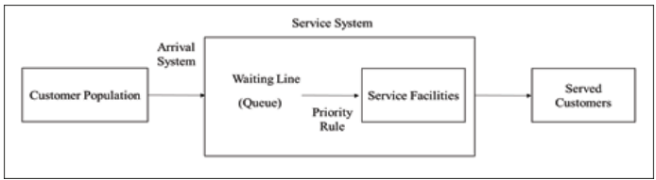

Figure 1: Queueing System (Source: Heizer & Render (2014))

The term "queuing discipline" refers to a set of rules that consumers must follow in order to be served. Customers must abide by the First In, First Out (FIFO) guideline. To put it another way, FIFO stood for First In, First Served (FIFS). This rule demonstrates that the first individuals in line will receive services before anyone else. The service system frequently makes use of the FIFS.(Mohamad, F., & Filza Saharin, S., 2019)[9]

The service facility comes last. It alludes to features like design and the statistical distribution of service delivery times. Included in this is the kind of server, which affects serving time and rate. Three different patterns of customer behavior exist, including jockeying, reneging, and balking (Upadhayay, 2017)[13].

1. Simulation

Simulation is a method for analyzing the behavior of a model in numerous situations in order to make a conclusion (Ghaleb, Suryahatmaja, & Alharkan, 2015)[1]. This simulation requires developing a model that represents the system. Therefore, the simulation will act as an operation of the system. After simulating the model, the real effects of each alternative and actions will be identified. According to the study of Vaisi, Raissi, & Vaisi (2015)[14], it is stated that it is important to make improvements in the actual system by using simulation. This is because the system's overall performance may be evaluated.

The study of Ghaleb et.al. (2015)[1] stated that simulation is an experiment of the model that represents real life. The process of how the system operated can be studied through simulation and prediction can be made if the variable changed. Simulation also acts as a tool to virtually investigate the performance of the system.

The operation of a system is represented as a discrete series of events in time via Discrete Event Simulation (DES). Each event occurs at a certain point in time and represents a change in the system's state (Sharma, 2015)[12]. According to Robinson (2015)[11], DES is often employed in the manufacturing system. However, it has risen quickly in the service sectors. According to Karnon et al. (2012)[6], DES is a user-friendly and adaptable method for solving complex systems using computer-based modelling. Furthermore, DES may be characterized as a versatile modelling tool capable of depicting complicated behavior within people, communities, and their settings. DES is the only simulation approach that gives distinct sequences of events in time.

1. Simulation Studies for Queueing Problem

Research related to queueing problems has been studied throughout the years. To solve this problem, several researchers choose to use discrete event simulation (DES). Wenjie et.al. (2015)[15] used a simulation tool to improve the efficiency of the operation at the supermarket. It is concluded in their study that the double-queueing system further shortens the staying time of customers, significantly reduces the operating cost and improves the operational efficiency of the supermarket.

Jhala and Bathawala (2017)[4] studied the application of queueing theory in supermarkets. They studied and analyzed a supermarket in India wherein there are three (3) checkout counters and also three (3) queues. With this, customers can select their own queue and they can also switch to a shorter queue (jockey behaviour of queue). It is concluded in their study that their proposed model, which is single queue multi-server is better in comparison to multi queue.

Kar (2014)[5] did research on the number of parking spots and the checkout system. In this study, SAS simulation studio was used to simulate and assess the services provided. The parking lot, conventional and express checkout counters are the simulation models in the study. All of the situations with various variables were simulated. The criteria were time of day, shopping trend, payment mechanism, and checkout system type. This research also stated that the model will be utilized as a guide for the decision-making process.

According to Upadhayay (2017)[13], constructing a simulation model is required to confirm the queuing theory. The research is about a bank ATM that used queue theory to shorten the length of the line. This theory necessitates the use of a mathematical model to calculate all of the data. In this study, it is said that constructing the simulation model would provide a reflection of the real operations when compared to the analytical model.

Lastly, a study about modelling pedestrian queuing by using micro-simulation was conducted by Kim et al., (2013)[7]. The model was developed with the details that included travel time, waiting for a time length of the queue, and the number of customers in waiting lines. The main purpose of this study is improving the queue without high costs.

1. METHODOLOGY

To complete this study, the simulation approach requires real-world data. As a result, all information for this study is gathered through observation, and time study. The data collected is time and volume related. The acquired data includes the number of customers queuing and the time it takes for each customer to complete the purchasing procedure at the checkout system. The data collected must be accurate in order for the system's results to be valid.

To view the actual performance, a simulation model was built using Simio simulation software. Moreover, the software also analyses the performance of the current system by using the data collected. The simulation runs for eight (8) hours, which is the complete store hours of ABC Supermarket. The model was simulated 10 times, which is 10 replications. After running the simulation model, statistical results were collected and recorded to analyze the data. Figure 3 shows the standard steps of the simulation process

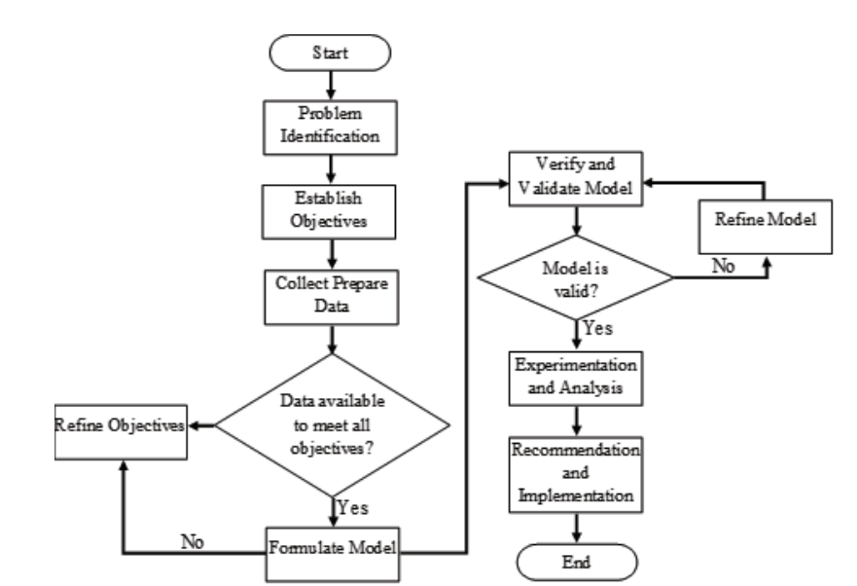

Figure 2: Simulation Modelling Process (Source: Centeno & Carrillo (2001))

The first step is to identify the problem that arises in the system being studied. The requirements for the system and process to be investigated were further outlined. Following the identification of issues, the objectives of this research must be established so that the researcher knows the method targeted at this study. The next step is to collect and prepare the data. Collect the information about the existing system and the data required to run the simulation. The data used to create the model and run it with Simio simulation software. If the data does not fulfil all of the objectives, the procedure of refining the objectives must be completed. The data must also be recollected and the model rebuilt. Otherwise, if the 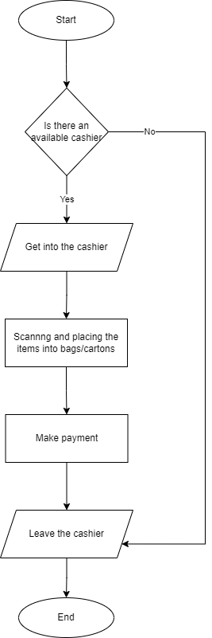data available satisfies all of the objectives, proceed to model formulation and model execution. The validation and verification process must be completed in order to obtain reliable results in this study. This procedure ensures that the model is appropriate. A verification model is a method that ensures that the model, including the virtual representation and implementation, is as intended. The model may be validated, but it is not valid. Validation ensures that there are no differences between the model and the actual system.

The model is validated with the use of two-tailed t-test and p value. The p-value is defined as the probability of getting a test statistic as extreme or more extreme than that observed by chance alone.

1. RESULTS AND ANALYSIS

The process flow of the checkout system is shown on Figure 4. This process is modelled to mimic the actual system by using Simio simulation software. Figure 5 shows the queuing system model using Simio simulation software.

Figure 4: Process Flow of Checkout System at ABC Supermarket

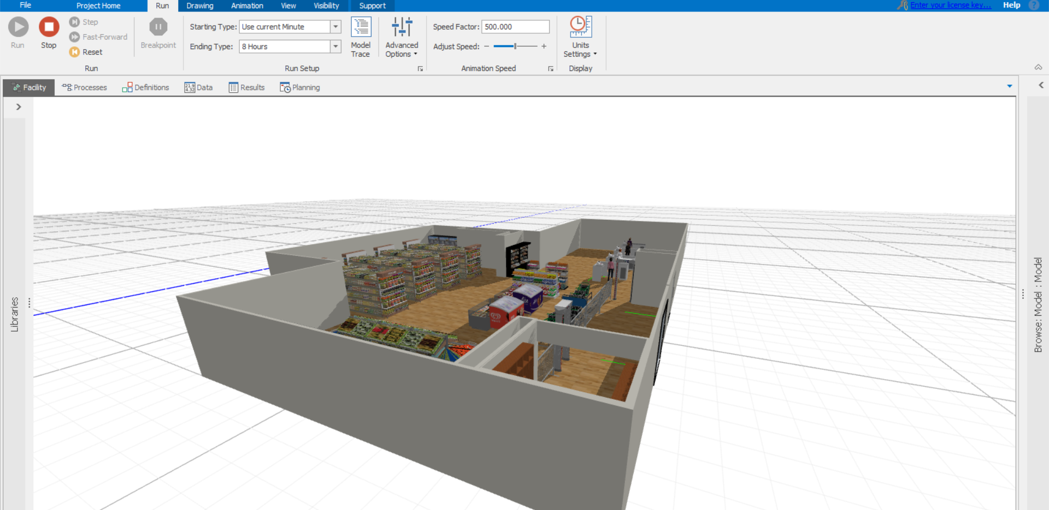

Figure 5: Queuing System Model using Simio Simulation Software

The researchers used Simio software to simulate the model. Ten (10) replications were done and the results were recorded in the excel file. The real-life system showed that the release volume of customers is an average of 78 people, while the model is 77 people. Therefore, the calculation of the p-value test is carried out. The value of p-value for this research is 0.3732, which signifies that the developed model has no significant difference with real life.

1. CONCLUSION

Supermarkets must enhance their service operations in order to attract more customers, develop loyalty, and satisfy customers. Even though waiting times and queues are common in a profit-making business, they must be improved to ensure customer satisfaction. This queuing system research consists of five processes: the customer selecting the cashier, entering the cashier, scanning and placing things in bags/cartons by the cashier, making a payment, and exiting the cashier. The simulation model was used to investigate the problem that these processes were experiencing. Simio simulation software was used to create and run the model. After that, the model requires the process of validation and verification.

The most efficient queuing system is to open four (4) checkout systems, which decreases the number of waiting times, the number of people waiting, and the number of people utilizing resources. Simio simulation is used throughout the process of developing the model and analyzing the system. By doing scenario analysis with the model developed, the modeling and simulation process decreases the risk of modifying the real system. This study introduces the simulation to be utilized to make a more timely and trustworthy conclusion.

This study shows that using Discrete Event Simulation (DES) as a computer-aided tool may assist management in improving the queue system at the supermarket. The researchers recommend that the future researchers must take into account the expense involved in determining the optimum scenario. The fundamental approach used in this study may be applied to other supermarkets or stores that use a similar operating system.

REFERENCES

[1] Ghaleb, M., Suryahatmaja, U.S., & Al-harkan, I.M. (2015). Modeling and simulation of Queuing Systems using arena software: A case study. *2015 International Conference on Industrial Engineering and Operations Management (IEOM)*, 1-7.

[2] Heizer, J., & Render, B. (2014). Operations Management: Sustainability and Supply Chain Management. (D. Battista, Ed.) (11th Editi). Pearson Education, Inc.

[3] Igwe, A., Onwumere, J. U. J., & Egbo, O. (2017). Efficient Queue Management in Supermarkets: A Case Study of Makurdi Town, Nigeria. *European Journal of Business and Management, 6*(39). https://core.ac.uk/download/pdf/234626158.pdf

[4] Jhala, N., & Bhathawala, P. (2017). Analysis and Application of Queuing Theory in Supermarkets. *International Journal of Innovative Research in Science, Engineering and Technology*, *6*(9). https://doi.org/10.15680/IJIRSET.2017.0609021

[5] Kar, L. S. (2014). An analysis of the number of parking bays and checkout counters for a supermarket using SAS simulation studio. *AIP Conference Proceedings*. https://doi.org/10.1063/1.4887760

[6] Karnon, J., Stahl, J., Brennan, A., Caro, J. J., Mar, J., & Möller, J. (2012). Modeling using Discrete Event Simulation: A Report of the ISPOR-SMDM Modeling Good Research Practices Task Force-4 Background to The Task Force. *Value in Health, 15*, 821–827. https://doi.org/10.1016/j.jval.2012.04.013

[7] Kim, I., Galiza, R., & Ferreira, L. (2013). Modeling pedestrian queuing using microsimulation. *Transportation Research Part A: Policy and Practice, 49,* 232–240. https: //doi.org/10.1016/j.tra.2013.01.018

[8] McClelland, W. G. (1962). Economics of the Supermarket. *The Economic Journal*, *72*(285), 154–170. https://doi.org/10.2307/2228621

[9] Mohamad, F., & Filza Saharin, S. (2019). Application of Discrete Event Simulation (DES) for Queuing System Improvement at Hypermarket. *KnE Social Sciences*. <https://doi.org/10.18502/kss.v3i22.5059>

[10] Priyangika, J. S. K. C., & Cooray, T. M. J. A. (2016). Analysis of the Sales Checkout Operation in Supermarket Using Queuing Theory. *Universal Journal of Management*, *4*(7), 393–396. https://doi.org/10.13189/ujm.2016.040703

[11] Robinson, S. (2015). Modelling without queues: Adapting discrete-event simulation for service operations. *Journal of Simulation, 9*(3), 195–205. https://doi.org/10.1057/ jos.2014.21

[12] Sharma, P. (2015). Discrete-Event Simulation. *International Journal of Scientific & Technology Research, 4*, 136-140.

[13] Upadhayay, A. (2017). Bank ATM Queuing Model: A Case Study, (5), 40–45

[14] Veisi, Bahar & Raissi, Sadigh & Vaisi, Ako. (2015). Simulation Based Strategy Using Data Envelope Analysis, Goal Programming for Increasing Customer Satisfaction in a Chain Store. *International Journal of Innovative Science, Engineering & Technology.*

[15] Wenjie, X., Senbiao, L., & Lihong, H. (2015). Simulation model of supermarket queuing system. *2015 34th Chinese Control Conference (CCC)*. https://doi.org/10.1109/chicc.2015.7261032